**EXPERIMENT NO. - 5**

**Object:** Determination of melt flow index of polymer material.

**Equipment**: M F I Tester

**Specification:** ASTM D 1525.

**Significance:** The melt flow index (MFI) or melt flow rate (MFR) is a measure for the ease

of flow of melted plastics. It is often used in the plastic industry for quality control of

thermoplastics. The method is described in the standards ASTM D1238 and ISO 1133.

The melt flow indexer is the most popular device in the plastic industry to determine

material viscosities and is often used to test batch-to-batch consistency. However, it is also

the least accurate method. A small sample of about 5 grams is heated above its melting or

softening point and forced to flow through a capillary using a piston actuated by a specified

weight, usually 2.16 kg or 5 kg. The weight of melt in grams flowing through the capillary

in 10 minutes is the melt flow index.

### MELT FLOW INDEXER

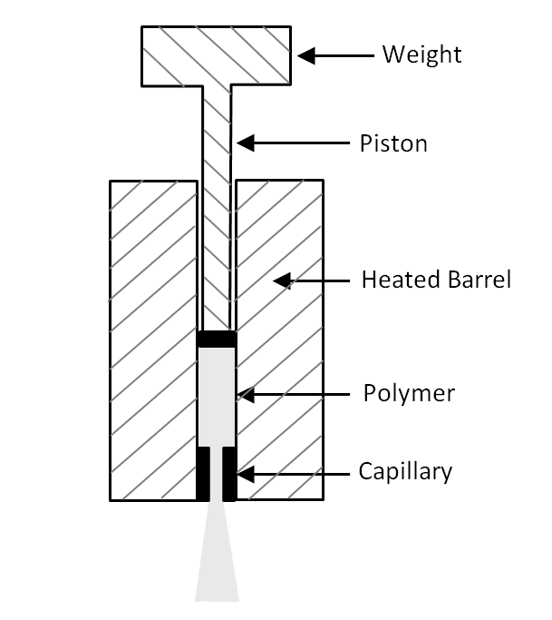

In general, a higher MFI indicates a lower material viscosity, and when comparing

polymers of the same class, a lower melt flow rate corresponds to a higher molecular

weight and/or less branching.

**Procedure:**

* A small amount of the polymer sample (around 4 to 5 grams) is taken in the specially designed MFI apparatus. A [die](https://en.wikipedia.org/wiki/Die_(manufacturing)) with an opening of typically around 2 mm diameter is inserted into the apparatus.
* The material is packed properly inside the barrel to avoid formation of [air](https://en.wikipedia.org/wiki/Air) pockets.
* A piston is introduced which acts as the medium that causes extrusion of the molten polymer.
* The sample is preheated for a specified amount of time: 5 min at 190 °C for [polyethylene](https://en.wikipedia.org/wiki/Polyethylene) and 6 min at 230 °C for [polypropylene](https://en.wikipedia.org/wiki/Polypropylene).
* After the preheating a specified weight is introduced onto the piston. Examples of standard weights are 2.16 kg, 5 kg, etc.
* The weight exerts a force on the molten polymer and it immediately starts flowing through the die.
* A sample of the melt is taken after the desired period of time and is weighed accurately.
* MFI is expressed in grams of polymer per 10 minutes of duration of the test.

**Results:** TheMelt Flow Index of the given polymer sample is -------------0C